

Faculty of Engineering Cairo University

CMPN301

Project Report

**Team: 32**

**Names:**

Maria Ossama Fathy 4180292

Passant Ahmed Maher 1170030

Lina Ayman Hamza 1170113

Rehab Ahmed Mohamed 1162297

**INDEX:**

|  |
| --- |
| 1. Full Design**. Page 3** |
|  |
| 1. Implemented parts and Non-implemented parts. **Page 4** |
|  |
| 1. Testcases with and without forwarding. **Page 5**   - Hazard detection unit effectiveness. **Page 13** |
|  |
| 1. Instruction Format. **Page 14** |
|  |
| 1. Opcodes. **Page 15** |
|  |
| 1. Assumptions. **Page 16** |
|  |
| 1. Interrupt Control Unit. **Page 17** |
|  |
| 1. Control Unit Truth Table. **Page 18** |
|  |

1. Full Design:

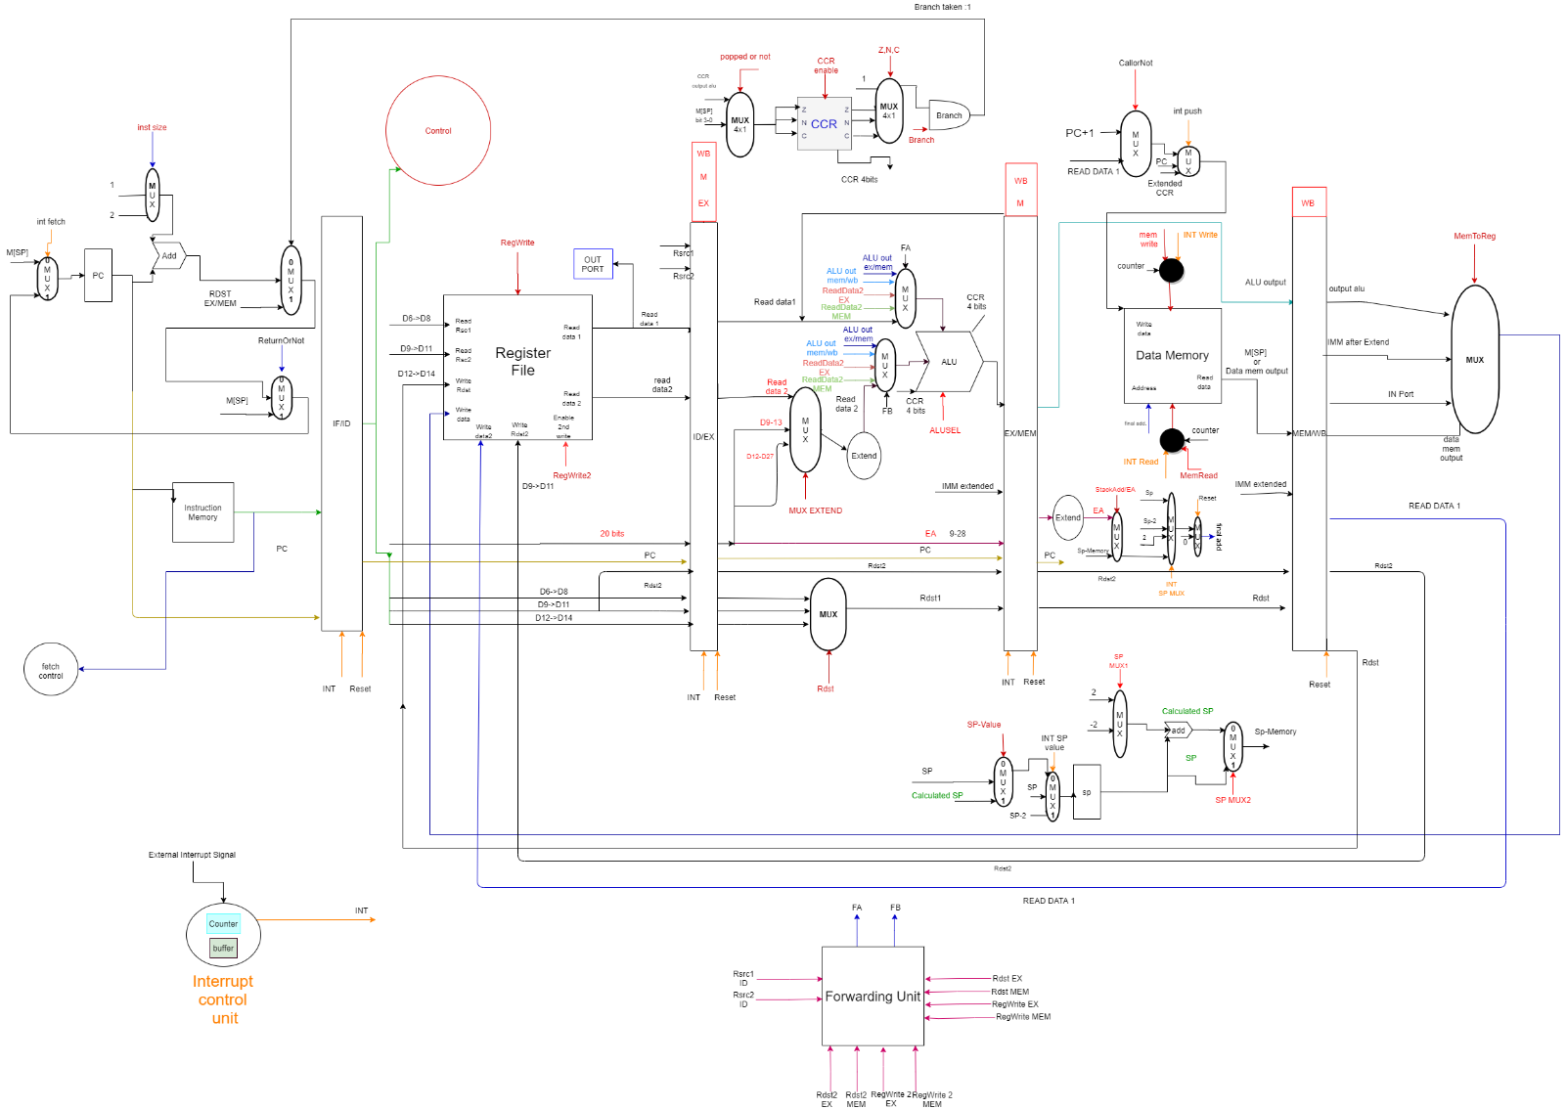

1. 1) Implemented and working parts:
2. Instructions:
3. **All One Operand Instructions are implemented and working.**
4. **Two Operand Instructions :** ADD, IADD,SUB,AND,OR,SHL,SHR.
5. **Memory Instructions:** LDM,LDD,STD.
6. **Branching Instructions:** JC,JZ,JN,JMP.
7. Forwarding Unit
8. Hazard Detection Unit

2) Non-Implemented parts:

1. Memory cache
2. Instructions:

**Branching Instructions:** CALL,RETURN,RTI,INT.

1. Interrupt control unit.

3) Implemented and non-working parts:

1. Instructions:
2. **Two Operand Instructions:** SWAP**.**
3. **Memory Instructions:** POP, PUSH.
4. **Testcases with and without forwarding:**

**One Operand Testcase:**

C🡪1 ,NOP,C🡪0,

NOT R1🡪FFFFFFFF ,

INC R1🡪 00000000,

IN R1 🡪 00000005 ,

IN R2 🡪 00000010,

NOT R2 🡪 FFFFFFEF,

INC R1🡪 00000006,

DEC R2🡪 FFFFFFEE,

OUT R1🡪00000006 , OUT R2🡪 FFFFFFEE.

1. **A. One Operand Testcase before implementing the Forwarding Unit:**

**Execution time= 2950 ps.**

Hazards found: Data hazards between R1 and R2 in most of the instructions, starting from instruction NOT R1, IN R1.

Solved by adding NOPs between each two instructions having data dependency.

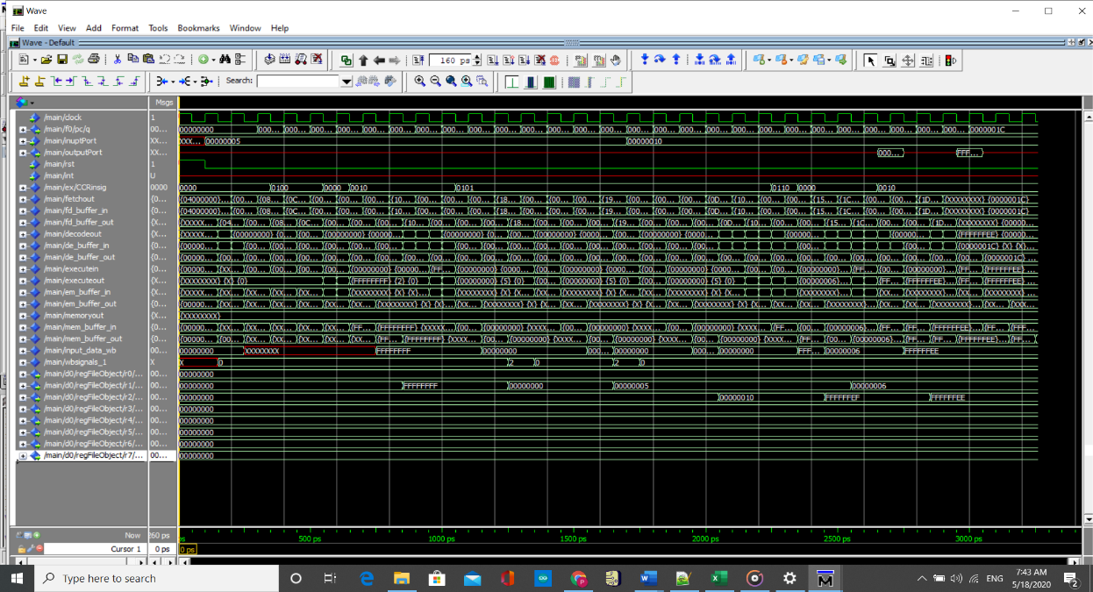

1. **B. One Operand Testcase after implementing the Forwarding Unit:**

**Execution time=1900 ps.**

We removed the NOPs, except for out as they are not forwarded and in instructions are memory-alu forwarded (using one nop instead of three)

.

* 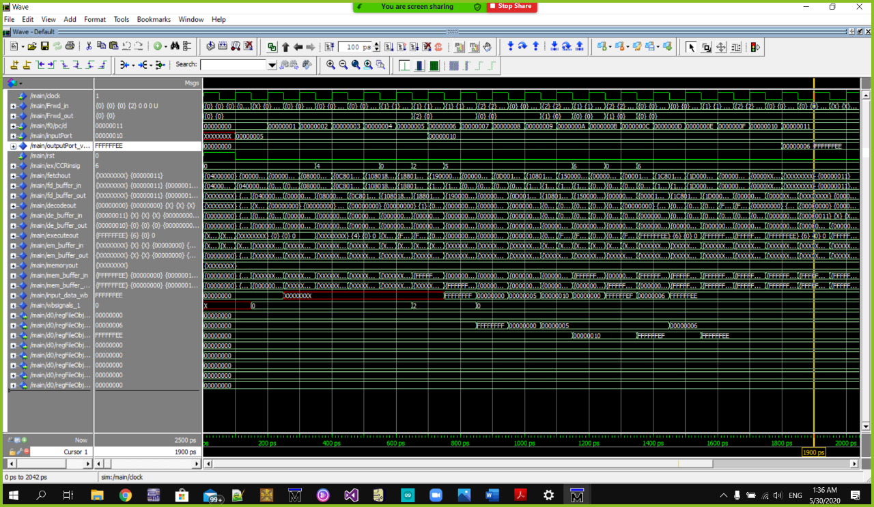**Speed up= 2950/1900 =1.55**

**Two Operands Testcase:**

IN R1 🡪00000005, IN R2 🡪 00000019 ,IN R3 🡪0000FFFD ,

IN R4 🡪0000F320,

IADD R3,R5,2 R5 🡪 0000FFFF

ADD R1,R4,R4 R4🡪 F325

SUB R5,R4,R6 R6🡪 0CDA ,

AND R7,R6,R6 R6🡪 00000000 ,

OR R2,R1,R1 R1 🡪0000001D ,

SHL R2,2 R2🡪00000064 ,

SHR R2,3 R2🡪0000000C ,

1. **A. Two Operands Testcase before implementing the Forwarding Unit:**

**Execution time=3100 ps.**

Data hazards in this testcase are solved by adding NOP before implementing the forwarding unit, which increases the number of instructions and execution time of the testcase.

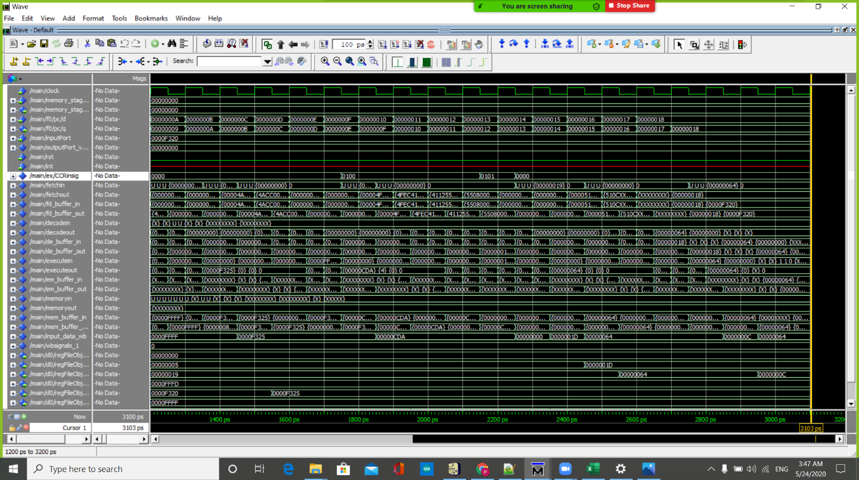

1. **B. Two Operand Testcase after implementing the Forwarding Unit:**

**Execution time= 1850 ps.**

We implemented full forwarding unit to solve the data hazards and we removed the NOPs that were added before.

* 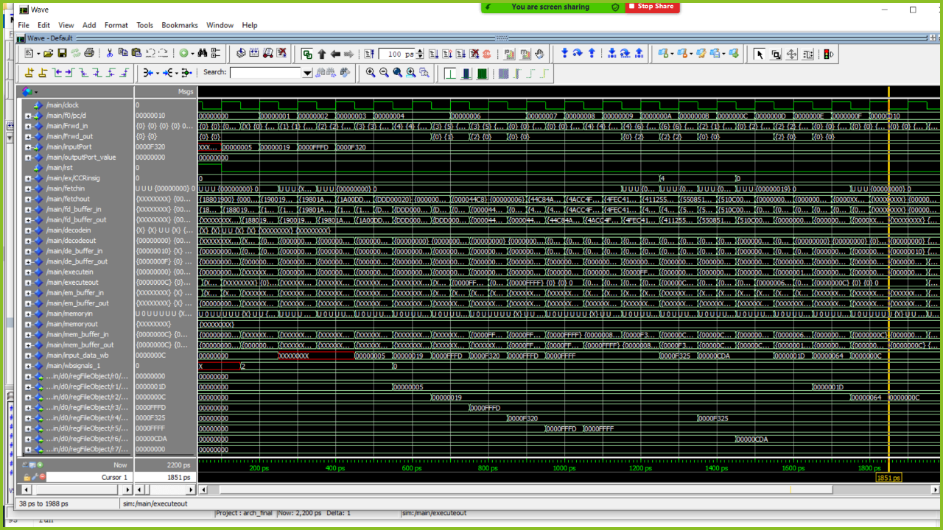**Speed up= 3100/1950 =1.59**

**Branching:**

* **Jump from PC (35) to PC (80)**

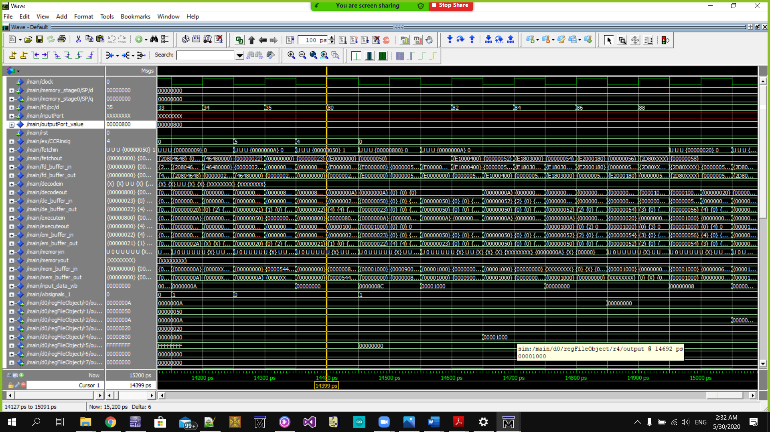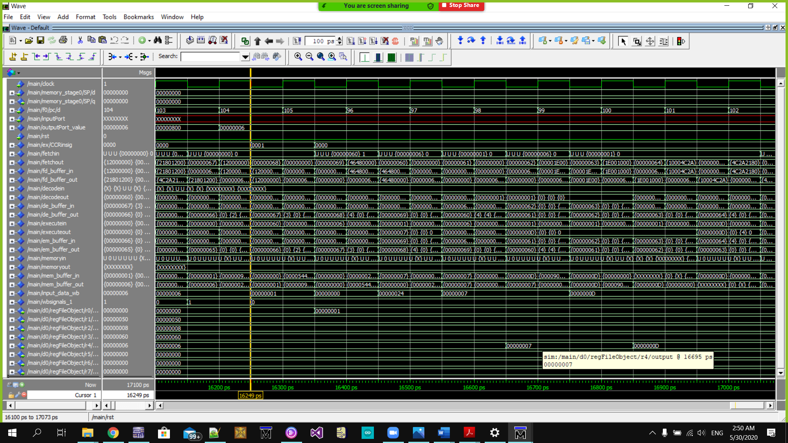

* **Jump from PC (105) to PC (96)**



**Branch Prediction Testcase:**

1. **The jumps before flushing**

* 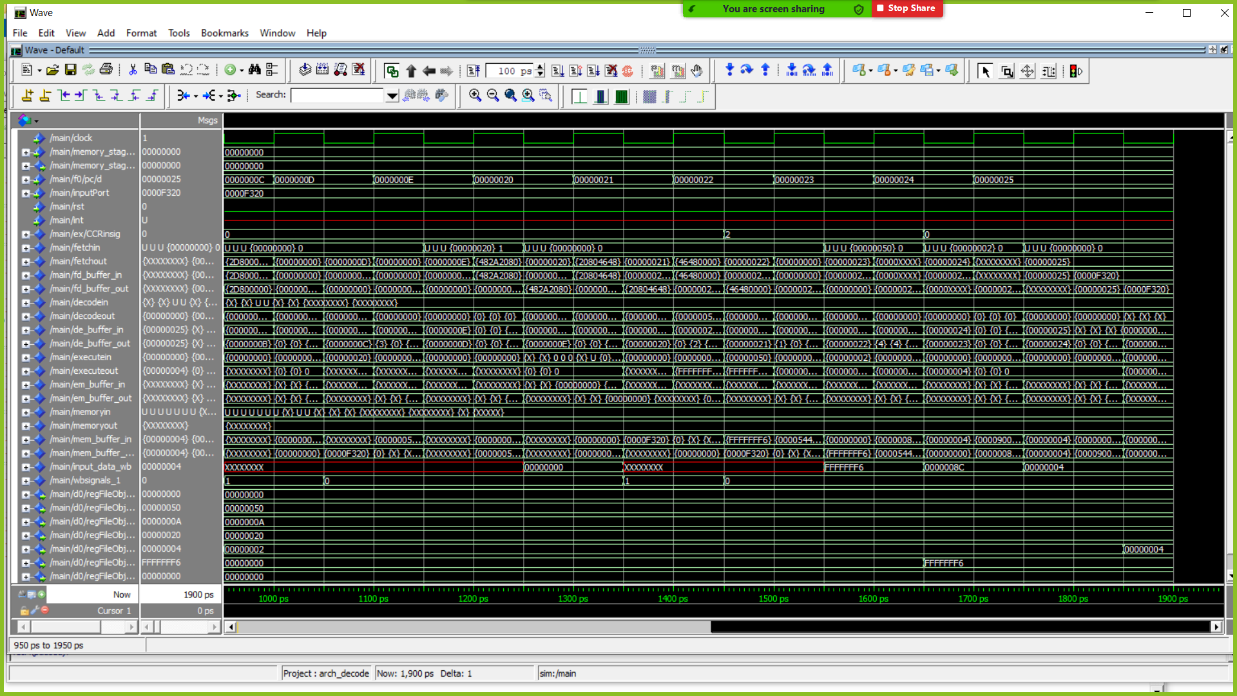 **Here is a jump to PC (20) without flushing and there is a value (FFFFFFF6) that has been written back due to not flushing at the falling of PC (24)**

1. **The jumps after flushing**

* **At the PC (20) where we jumped The Fetch/Decode buffer and Decode/Execute buffer are flushed (wrong instruction in decode and execute stages) and the wrong value that was written back at the falling of PC (24) isn’t written anymore**

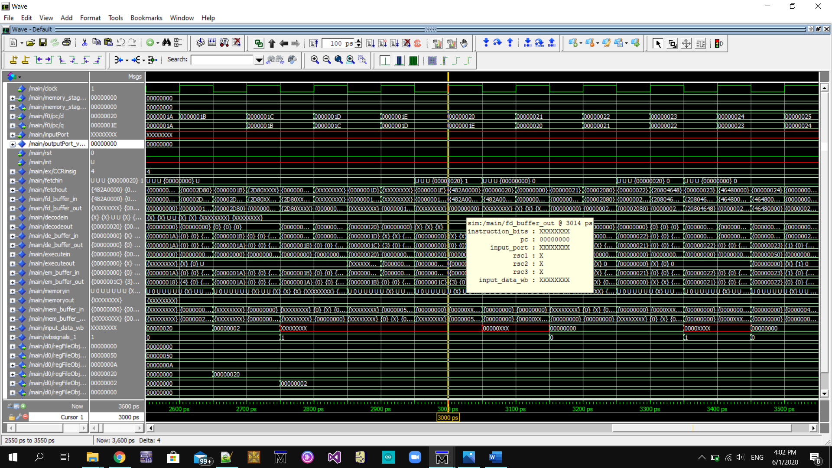

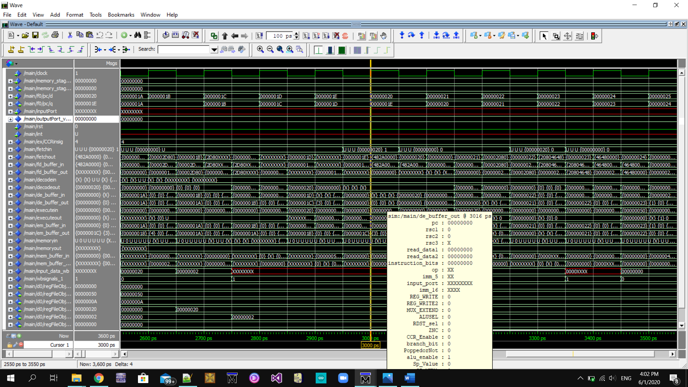

**Memory Testcase:**

**Memory Contents:**

**Implemented memory Instructions in this Test Case: LDD,LDM and STD.**

* **in R2 #R2=0CDAFE19**
* **in R3 #R3=FFFF**
* **in R4 #R4=F320**
* 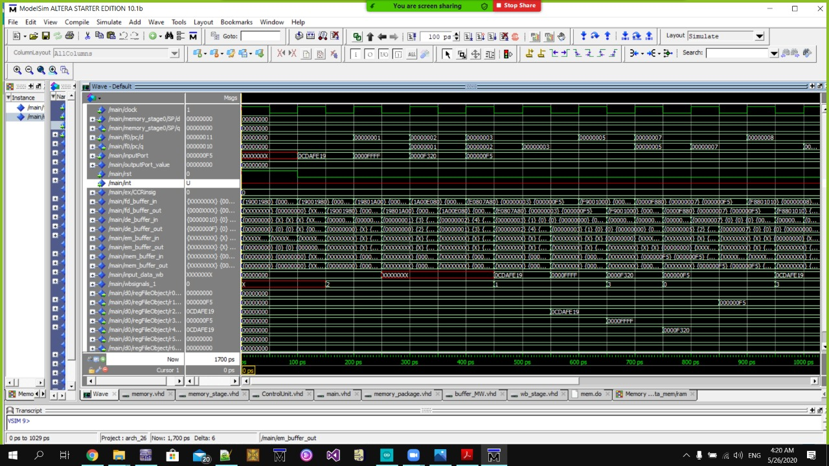**LDM R1,F5 #R1=F5**
* **STD R2,200 #M[200, 201]=F5**
* 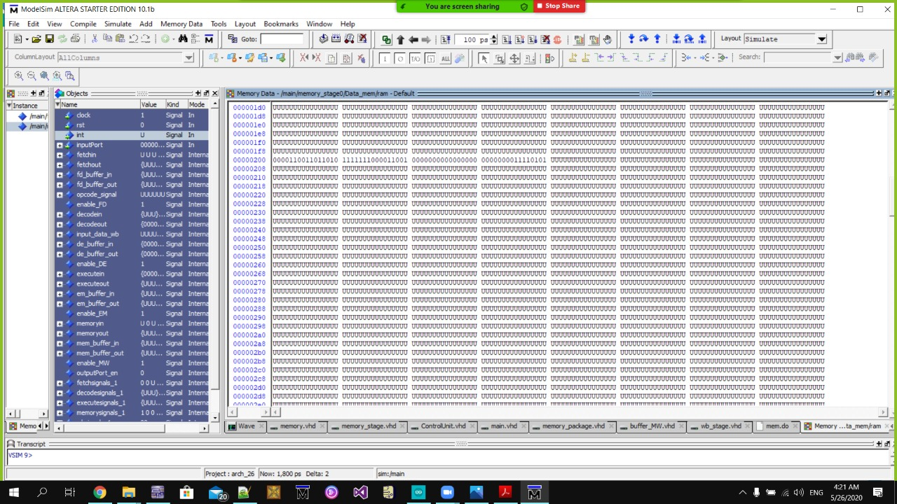**STD R1,202 #M[202, 203]=0CDAFE1**
* **LDD R3,202 #R3=5**
* **LDD R4,200 #R4=0CDAFE19**

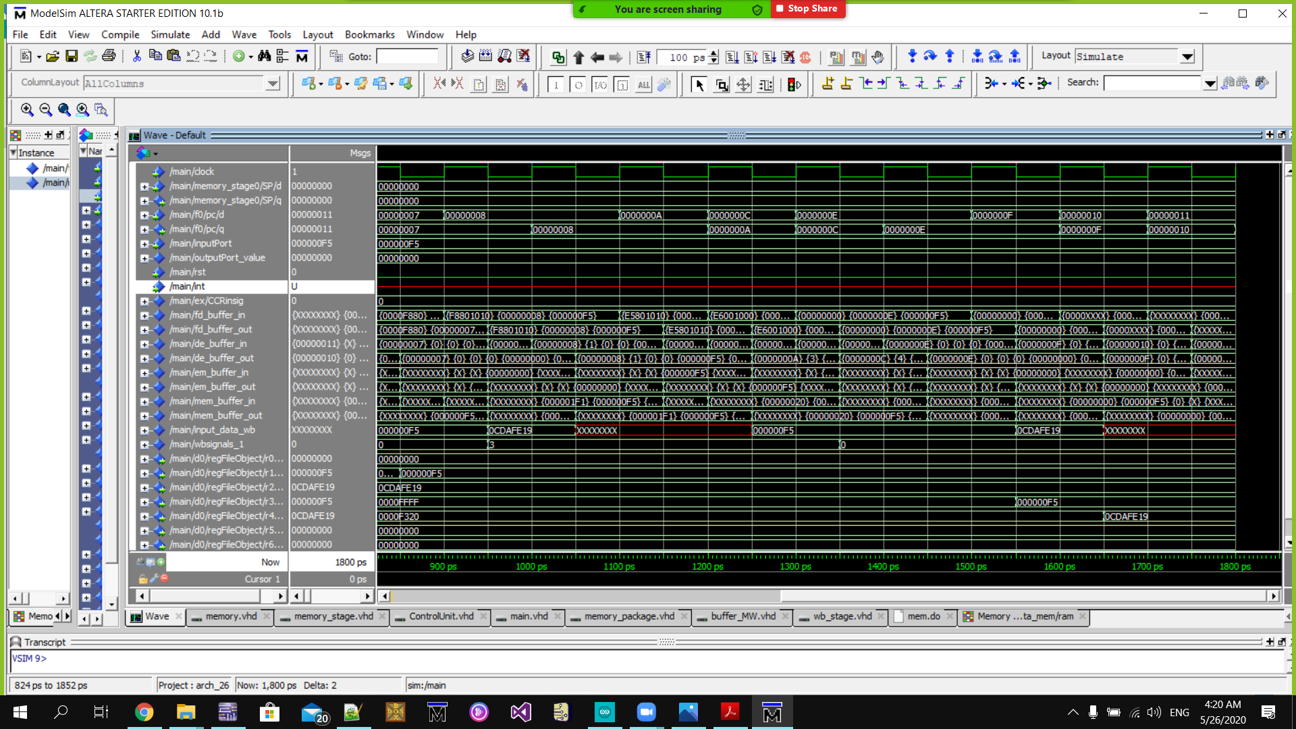

**Memory Testcase after the hazard detection unit:**

**We implemented the hazard detection unit to stall and in this screenshot the stall signal is zero which enter to the Fetch/Decode buffer enable otherwise it’s 1 and all the control signals of the control unit**

* **LDM R1,F5**
* **STD R1,202**
* **LDD R3,202**
* **NOT R3**

**Decode stage control signals before the stall signal to be zero:** still have values

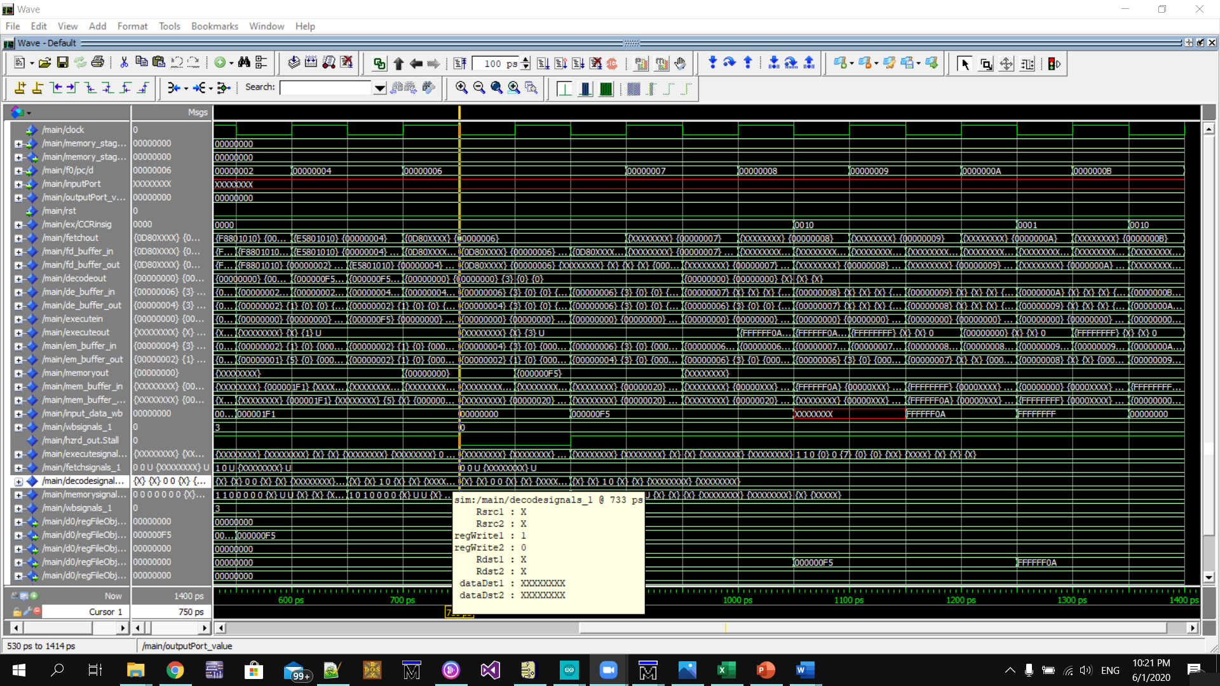

**Decode stage control signals after the stall signal to be one:** all values are zero

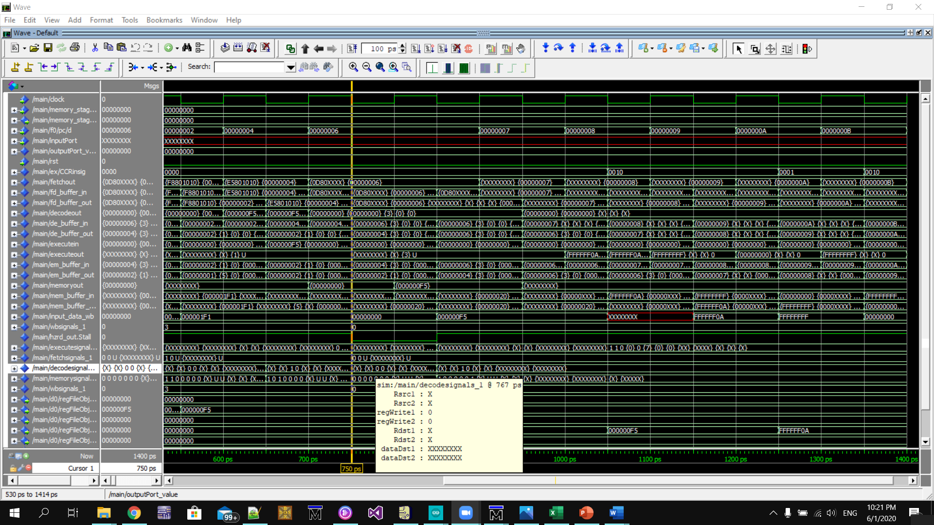

1. Instruction Format

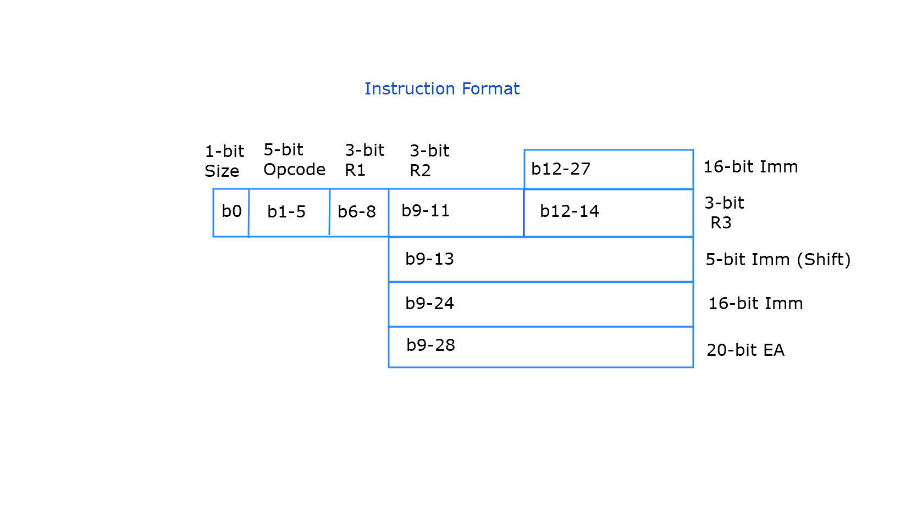

B0 🡪 Size bit: 0 for 16 -bit instructions , 1 for 32-bit instructions.

B1-B5 🡪5-bit op-code and function bits to represent the 28 instructions.

B6-B8 🡪 3-bit to represent the first register number.

B9-B11 🡪 3-bit to represent the second register number.

B12-B14 🡪 3-bit to represent the third register number.

B9-B24 and B12-B27 🡪 16-bit Immediate Value.

B9-B28 🡪 20-bit Effective Address.

B9-13 🡪 5-bit Immediate Value for shift operations.

1. Opcodes

|  |  |
| --- | --- |
| Instruction | Opcode |
| NOP | 000000 |
| SETC | 000001 |
| CLRC | 000010 |
| NOT RDST | 000011 |
| INC RDST | 000100 |
| DEC RDST | 000101 |
| OUT RDST | 000111 |
| IN RDST | 000110 |
| JZ | 001000 |
| JN | 001001 |
| JC | 001010 |
| JMP | 001011 |
| CALL | 001100 |
| RET | 001101 |
| RTI | 001110 |
| OR RSRC1,RSRC2,RDST | 010000 |
| ADD RSRC1,RSRC2,RDST | 010001 |
| SUB RSRC1,RSRC2,RDST | 010010 |
| AND RSRC1,RSRC,RDST | 010011 |
| SHR | 010100 |
| SHL | 010101 |
| SWAP | 010110 |
| IADD | 110111 |
| LDM | 111000 |
| LDD | 111001 |
| STD | 111110 |
| POP | 011100 |
| PUSH | 011101 |

1. Assumptions:
2. The bus between the memory and the processor is 32-bit width.

-The PC is either added by 1 for 16-bit instructions and by 2 for 32-bit instructions based on the size bit (b0).

1. Interrupt was to be implemented within 3 clock cycles.

The first cycle 🡪 Pushing the PC value.

The second cycle 🡪 Pushing the flag register (CCR).

The third cycle 🡪 Reading Memory location 2 and 3 (in half cycle) and write it’s value in PC( in the other half).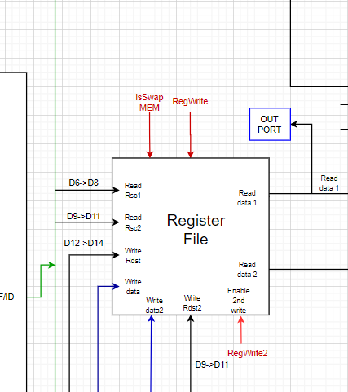

1. Swap instruction was to be implemented in one cycle

Register file has write Rdst1, write data1, write Rdst2, write data2

We added a control signal “RegWrite2” to enable writing in Rdst2

Rdst2 takes Rdst2 bits from 9-11

Write data2 takes read data1

1. Value of CCR is updated as a function of the ALU
2. The stack pointer (SP) points to the first available 32 bits, and gets added/subtracted by 2.
3. Reset signal is connected to the reset input in each buffer, and hence the reset operation resets the buffers and changes the PC value to the value in memory location 0 and 1.
4. For branching instructions, the processor predicts not taken where,

the decision is made in the execution stage except for call and ret instructions as they are always taken therefore we need to flush two instructions that are being fetched and decoded while a branching instruction is being executed.

For conditional jumps, the flag bit is anded with branch signal (from control unit), therefore the branch is taken if both are 1.

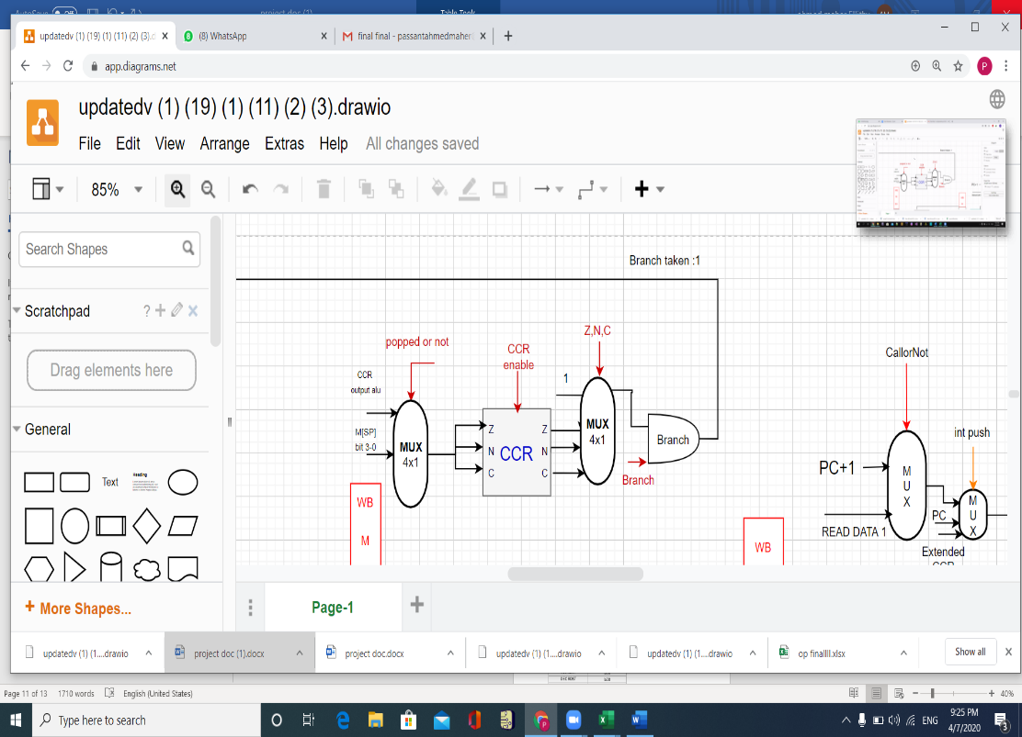The MUX with ZNC selector outputs 1 in case of unconditional Jump/Call/RET.

1. Interrupt control unit (Not implemented).

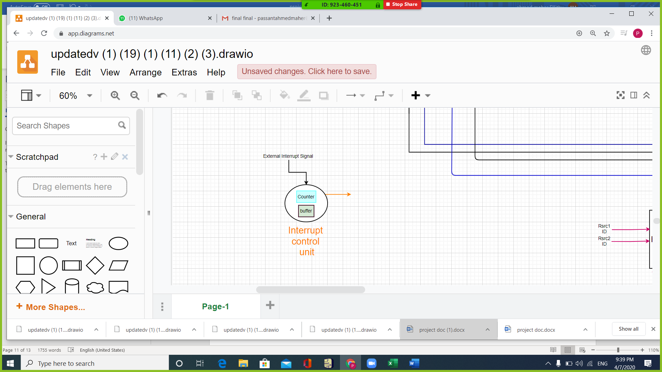

Interrupt control unit : it takes 3 cycles to execute the interrupt so we close all the intermediate buffers except the MEM/W buffer with INT signal where there is a 2 bits counter.

In the data memory when there is an interrupt signal in the first 2 cycles we take the INT write signal as enable to the write data and we neglect the mem write signal(control unit).

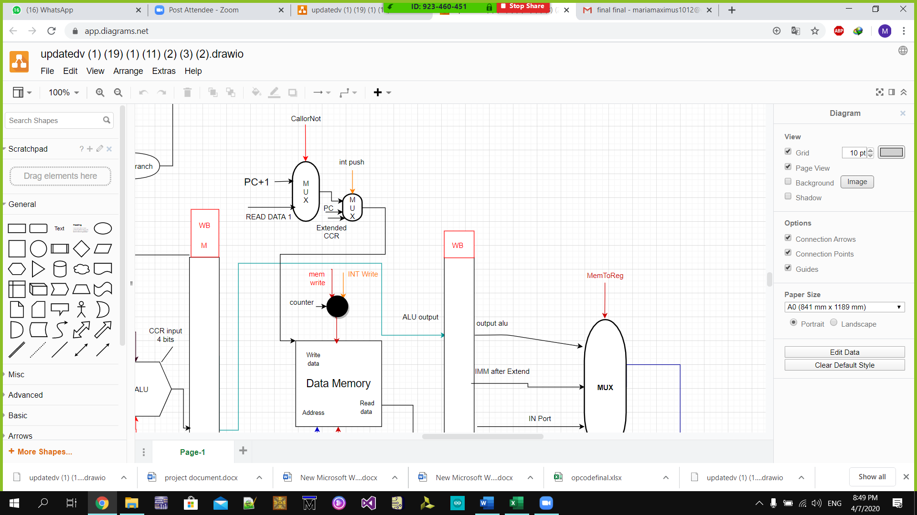

In the 3rd cycle the INT read signal has control over the memory read enable

1st cycle (counter 00) : we push the PC in the M[sp] then sp-2

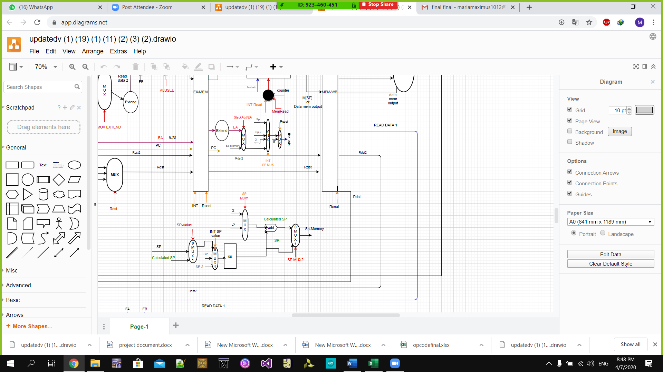

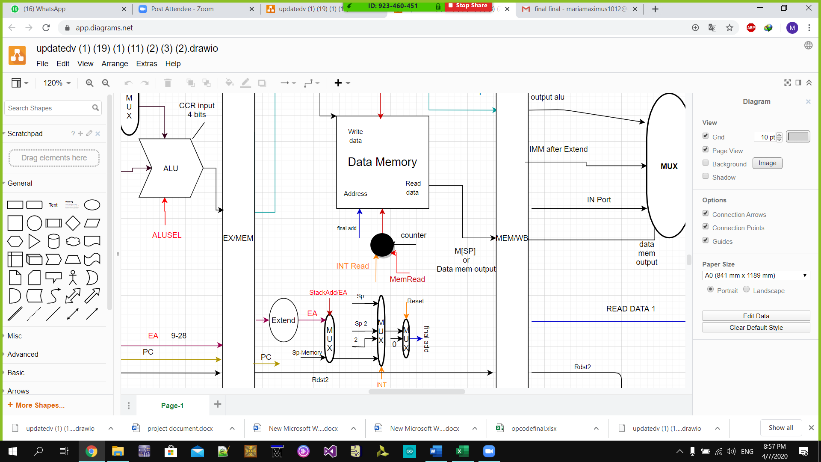

2nd cycle (counter 01) : we push the flags(CCR extended to 32 bits) then sp-2

3rd cycle (counter 10) : we read M[2]M[3] in the first half cycle then we write this memory

address in the PC in the other half cycle

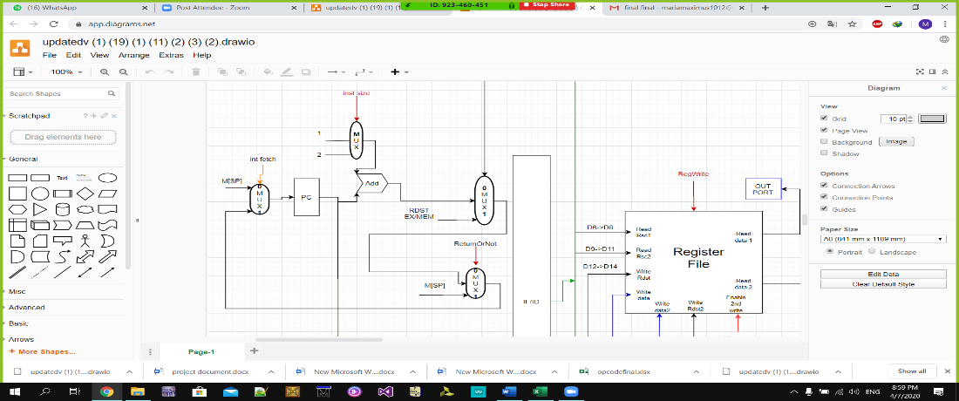

At counter 11 this means there is no interrupt and we will set the counter to 00 when an interrupt signal is fired again

|  |  |  |  |  |  |  |  |
| --- | --- | --- | --- | --- | --- | --- | --- |
| counter | INT | INT read | INT push | INT write | INT Spvalue | INT Spmux | INT fetch |
| b00 | 0 | 1 | b01 | 1 | b10 | b00 | 1 |
| b01 | 0 | 1 | b10 | 1 | b10 | b01 | 1 |
| b10 | 0 | 1 | x | 0 | b01 | b10 | 0 |
| b11 | 1 | X | b00 | x | b00 | b11 | 1 |

Control Unit truth table:

1. IF control signals

|  |  |  |
| --- | --- | --- |
| **Instruction** | InstSize | ReturnorNot |
| NOP | 0 | 0 |
| SETC | 0 | 0 |
| CLRC | 0 | 0 |
| NOT RDST | X | 0 |
| INC RDST | 0 | 0 |
| DEC RDST | 0 | 0 |
| OUT RDST | 0 | 0 |
| IN RDST | 0 | 0 |
| JZ | 0 | 0 |
| JN | 0 | 0 |
| JC | 0 | 0 |
| JMP | 0 | 0 |
| CALL | 0 | 0 |
| RET | 0 | 1 |
| RTI | 0 |  |
| X | X | 0 |
| OR RSRC1,RSRC2,RDST | 0 | 0 |
| ADD RSRC1,RSRC2,RDST | 0 | 0 |
| SUB RSRC1,RSRC2,RDST | 0 | 0 |
| AND RSRC1,RSRC,RDST | 0 | 0 |
| SHR | 0 | 0 |
| SHL | 0 | 0 |
| SWAP | 0 | 0 |
| IADD | 1 | 0 |
| LDM | 1 | 0 |
| LDD | 1 | 0 |
| X | X | X |
| X | X | X |
| POP | 0 | 0 |
| PUSH | 0 | 0 |
| STD | 1 | 0 |
| X | X | X |

1. ID control signals

|  |  |  |
| --- | --- | --- |
| **Instruction** | REG WRITE | REG WRITE2 |
| NOP | 0 | 0 |
| SETC | 0 | 0 |
| CLRC | 0 | 0 |
| NOT RDST | 1 | 0 |
| INC RDST | 1 | 0 |
| DEC RDST | 1 | 0 |
| OUT RDST | 0 | 0 |
| IN RDST | 1 | 0 |
| JZ | 0 | 0 |
| JN | 0 | 0 |
| JC | 0 | 0 |
| JMP | 0 | 0 |
| CALL | 0 | 0 |
| RET | 0 | 0 |
| RTI | 0 | 0 |
| X | X | 0 |
| OR RSRC1,RSRC2,RDST | 1 | 0 |
| ADD RSRC1,RSRC2,RDST | 1 | 0 |
| SUB RSRC1,RSRC2,RDST | 1 | 0 |
| AND RSRC1,RSRC,RDST | 1 | 0 |
| SHR | 1 | 0 |
| SHL | 1 | 0 |
| SWAP | 1 | 1 |
| IADD | 1 | 0 |
| LDM | 1 | 0 |
| LDD | 1 | 0 |
| X | X | 0 |
| X | X | 0 |
| POP | 0 | 0 |
| PUSH | 0 | 0 |
| STD | 0 | 0 |
| X |  |  |

1. IE control signals

|  |  |  |  |  |  |  |  |
| --- | --- | --- | --- | --- | --- | --- | --- |
| **Instruction** | MUX EXTEND | ALUSEL | RDST | ZNC | CCR Enable | branch bit | Popped orNot |
| NOP | XX | b1111 | b00 | X | 0 | 0 | 0 |
| SETC | XX | b1111 | b00 | X | 0 | 0 | 0 |
| CLRC | XX | b1001 | b00 | X | 0 | 0 | 0 |
| NOT RDST | ZZ | b1111 | b00 | X | 1 | 0 | 0 |
| INC RDST | ZZ | b0000 | b00 | X | 1 | 0 | 0 |
| DEC RDST | ZZ | b0011 | b00 | X | 1 | 0 | 0 |
| OUT RDST | XX | b1111 | b00 | X | 0 | 0 | 0 |
| IN RDST | XX | b1111 | b00 | X | 0 | 0 | 0 |
| JZ | XX | b1010 | b00 | B01 | 1 | 1 | 0 |
| JN | XX | b1011 | b00 | B10 | 1 | 1 | 0 |
| JC | XX | b1001 | b00 | B11 | 1 | 1 | 0 |
| JMP | XX | b1111 | b00 | b00 | 0 | 1 | 0 |
| CALL | XX | b1111 | b00 | b00 | 0 | 1 | 0 |
| RET | XX | b1111 | b00- | b00 | 0 | 1 | 0 |
| RTI | XX | b1111 | b00- | b00 | 0 | 1 | 1 |
| X | XX | b1111 | X | X | 0 | 0 | 0 |
| OR RSRC1,RSRC2,RDST | b00 | b0101 | b10 | X | 1 | 0 | 0 |
| ADD RSRC1,RSRC2,RDST | b00 | b0001 | b10 | X | 1 | 0 | 0 |
| SUB RSRC1,RSRC2,RDST | b00 | b0010 | b10 | X | 1 | 0 | 0 |
| AND RSRC1,RSRC,RDST | b00 | b0100 | b10 | X | 1 | 0 | 0 |
| SHR | b01 | b1000 | b00 | X | 1 | 0 | 0 |
| SHL | b01 | b1100 | b00 | X | 1 | 0 | 0 |
| SWAP | b00 | b1110 | b00 | b00 | 0 | 0 | 0 |
| IADD | b00 | b0001 | b01 | X | 1 | 0 | 0 |
| LDM | b11 | b1111 | b00 | b00 | 0 | 0 | 0 |
| LDD | b10 | b1111 | b00 | b00 | 0 | 0 | 0 |
| X | XX | b1111 | X | b00 | 0 | 0 | 0 |
| X | XX | b1111 | X | b00 | 0 | 0 | 0 |
| POP | ZZ | b1111 | b00 | b00 | 0 | 0 | 0 |
| PUSH | ZZ | b1111 | b00 | b00 | 0 | 0 | 0 |
| STD | b10 | b1111 | b00- | b00 | 0 | 0 | 0 |
| X | XX | b1111 | X | b00 | 0 | 0 | 0 |

1. Memory control signals

|  |  |  |  |  |  |  |  |
| --- | --- | --- | --- | --- | --- | --- | --- |
| **Instruction** | Sp-Value | SP MUX1 | SP MUX2 | callornot | MEM READ | MEM WRITE | StackAdd/EA |
| NOP | 0 | x | 1 | 1 | 0 | 0 | 0 |
| SETC | 0 | x | 1 | 1 | 0 | 0 | 0 |
| CLRC | 0 | x | 1 | 1 | 0 | 0 | 0 |
| NOT RDST | 0 | x | 1 | x | 0 | 0 | 0 |
| INC RDST | 0 | x | 1 | 1 | 0 | 0 | 0 |
| DEC RDST | 0 | x | 1 | 1 | 0 | 0 | 0 |
| OUT RDST | 0 | x | 1 | 1 | 0 | 0 | 0 |
| IN RDST | 0 | x | 1 | 1 | 0 | 0 | 0 |
| JZ | 0 | x | 1 | 1 | 0 | 0 | 0 |
| JN | 0 | x | 1 | 1 | 0 | 0 | 0 |
| JC | 0 | x | 1 | 1 | 0 | 0 | 0 |
| JMP | 0 | x | 1 | 1 | 0 | 0 | 0 |
| CALL | 1 | 1 | 1 | 0 | 0 | 1 | 1 |
| RET | 1 | 0 | 0 | 1 | 1 | 0 | 1 |
| RTI | 1 | 0 | 0 | ? | 1 | 0 | 1 |
| X | 0 | x | 1 | x | X | X | x |
| OR RSRC1,RSRC2,RDST | 0 | x | 1 | 1 | 0 | 0 | 0 |
| ADD RSRC1,RSRC2,RDST | 0 | x | 1 | 1 | 0 | 0 | 0 |
| SUB RSRC1,RSRC2,RDST | 0 | x | 1 | 1 | 0 | 0 | 0 |
| AND RSRC1,RSRC,RDST | 0 | x | 1 | 1 | 0 | 0 | 0 |
| SHR | 0 | x | 1 | 1 | 0 | 0 | 0 |
| SHL | 0 | x | 1 | 1 | 0 | 0 | 0 |
| SWAP | 0 | x | 1 | 1 | 0 | 0 | 0 |
| IADD | 0 | x | 1 | 1 | 0 | 0 | 0 |
| LDM | 0 | x | 1 | 1 | 0 | 0 | 0 |
| LDD | 0 | x | 1 | 1 | 1 | 0 | 0 |
| X |  | x | 1 | x | X | X | x |
| X |  | x | 1 | x | X | X | x |
| POP | 1 | 0 | 0 | 1 | 1 | 0 | 1 |
| PUSH | 0 | 1 | 0 | 1 | 0 | 1 | 1 |
| STD | 0 | x | 1 | 1 | 0 | 1 | 0 |
| X |  | x | x | x | X | X | x |

1. WB control signals

|  |  |
| --- | --- |
| **Instruction** | MEM TO REG |
| NOP | b00 |
| SETC | b00 |
| CLRC | b00 |
| NOT RDST | b00 |
| INC RDST | b00 |
| DEC RDST | b00 |
| OUT RDST | b00 |
| IN RDST | b00 |
| JZ | b01 |
| JN | b01 |
| JC | b01 |
| JMP | b01 |
| CALL | b01 |
| RET | b00 |
| RTI | b00 |
| X |  |
| OR RSRC1,RSRC2,RDST | b00 |
| ADD RSRC1,RSRC2,RDST | b00 |
| SUB RSRC1,RSRC2,RDST | b00 |
| AND RSRC1,RSRC,RDST | b00 |
| SHR | b00 |
| SHL | B00 |
| SWAP | b00 |
| IADD | b00 |
| LDM | b10 |
| LDD | b11 |
| X |  |
| X |  |
| POP | b10 |
| PUSH | b00 |
| STD | b00 |
| X |  |